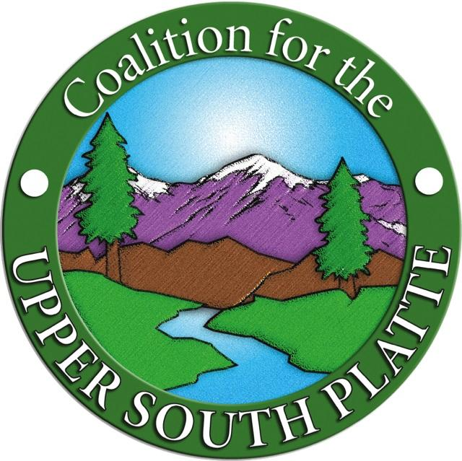
Coalition for the Upper South Platte (CUSP)
40 Cherokee Avenue
PO Box 726
Lake George, CO 80827
719-748-0033 (office)

Contract Administrator:
Chris Fuller
Coalition for the Upper South Platte (CUSP)
40 Cherokee Avenue
PO Box 726
Lake George, CO 80827
chris@cusp.ws
719-748-0033

Project Administrator:
Adrian Knight, Staff Forester
Coalition for the Upper South Platte (CUSP)
40 Cherokee Avenue
PO Box 726
Lake George, CO 80827
adrian@cusp.ws
719-640-6985 cell

Project:
Tree thinning and fire mitigation on the common area in the Crystal Park subdivision near Manitou Springs. Hand work will need to be used as machine access is limited. In areas where machine access exists, machines can be used.

Property Location:
Crystal Park is located 3 miles south of Manitou Springs. Work will take place on Crystal Park common area totaling 10 acres.

Contents:
Project Overview and Timeline
Bid Approach
Property Descriptions
Prescription
Project Purpose
Contractor Task Summary
Bid Submittal Requirements
Selection Procedure and Criteria
Contractor Expectations
Appendices

Project Overview:
Work will take place on common area in the Crystal Park subdivision outside of Manitou Springs. The project area is 10 acres. Slopes in the project area range from mild to very steep. The main access to the project area is off Crystal Park Rd. and down a steep slope, making machine access difficult. Where hand work is used lop and scatter will be used.

Project Objectives:
Improve forest health
Reduce hazardous fuels
Enhance wildlife habitat
Mitigate insects and disease
Enhance aesthetics
Detailed descriptions for these objectives are listed in the Appendix 2.

Project Timeline:
RFP Released: Wednesday, June 26, 2024
Show-Me-Tour: Monday, July 15, 2024 9:00 am at the gate for Crystal Park, 805 Crystal Park Rd, Manitou Springs, CO 80829
Bids Due: Friday, July 19, 2024
Project Start: ASAP

Bid Approach:
The contractor will bid based on their determination of the most effective and cost-efficient strategy for implementing a mixed conifer restoration prescription on a cost/per acre basis.

Property Description:
Crystal Park is located south of Manitou Springs. Work will take place on common area with slope ranging from mild to very steep. The area is predominately a dry mixed conifer forest with Douglas fir, ponderosa pine, Gambel oak, and aspen. Tree stands are overstocked with declining, small diameter understory interspersed with standing dead and robust, larger diameter overstory. Continuous canopy characterizes this region’s forested areas and these project areas.

Prescription:
The proposed treatments will remove the dense understory and convert
the declining forest conditions to more robust forest overall with open crown conditions
indicative of south-facing slopes and canopy openings created on north facing slopes through
tree removal. The resultant forest will be more resistant to wildland fire spread, will provide a
more open habitat for wildlife, and will help to return the landscape to a more natural
trajectory. Canopy cover will be reduced 50% or more through this prescription.

Work will remove <8” dbh trees, generally retaining trees >9” dbh, while separating given groups of trees from other groups within the stands on cooler north-facing slopes to achieve basal area of 60-80. On drier south-facing slopes, desired basal area below 60 will be achieved by retaining single large trees and isolating small groups of 2-5 large trees along with larger groups of trees of variable size, age, and species. The focus is to retain ponderosa pine over Douglas-fir. Throughout these areas, aspen stands are limited and declining due to D-fir competition and consistent 20-yr drought conditions, although aspen exists within the mixed conifer. Hand thinning will be used to remove conifer understory within aspen clumps and machine work to remove conifers to a distance of one tree height (average height of aspen in the stand) around the edges of aspen clumps to encourage enlargement of clumps. Drainages treated with handwork will retain higher density trees than across slopes, especially in north-facing areas. As needed in minimal areas, trees will be contour-felled, retained and installed as erosion barriers.

Where oak is present, stems will be thinned to create openings between retained oak. Retained oak patches will be no larger than 1.5 times the height of the tallest stem in diameter, and retained clumps will be more than 1.5 times the height of the tallest stem apart from each other.

Where possible, slash will be masticated to <6” material length and < 3” material depth or chipped to < 3” chip size and < 3” chip depth. Chipped material will not exceed 40-60% cover of the forest floor. Slash will be lopped and scattered when it is not feasible to chip or masticate. Lop and Scatter will not exceed 12” in depth and 36” in length.

Any ground disruptions due to operations will be smoothed as necessary.

Project Purpose:
This forest thinning will reduce forest density and increase forest resilience to disturbances particularly fire. Thinning will increase tree vigor, understory production, wildlife habitat and make tree stands more resilient to the effects of drought and insect and disease outbreaks. The desire is to restore the forest to a more natural trajectory where diversity of stand density, species, age and size class trees are represented across the larger landscape while increasing the survivability of the homes on surrounding properties.

Contractor Task Summary:
The specific tasks for which we are seeking services are summarized below. A detailed explanation of prescriptions and additional pertinent information may be found in the Appendix.

- Treat 10 acres using hand work, and if possible, machinery.
- Masticated material will be fine ground to material length no greater than 6 inches and distributed evenly to a depth not to exceed 2-3” on average. Material shall not exceed 40-60% cover of forest floor. Slash to be chipped will be broadcast on site. Chip size will be no greater than 3 inches on average and chip depth will not exceed 2-3” on average.
- Lop and scatter shall not exceed 12 inches in depth and 36 inches in length and shall not exceed 30% cover of forest floor.
- Boles will be cut into 6-8’ lengths and stacked onsite.
- All ground disruptions due to operations will be smoothed, and where necessary, erosion control measures will need to be taken.
- Boundary areas will be marked with pink flagging, double flagged trees representing corners, and will be identified by CUSP Project Manager.
Bid Submittal Requirements:

- Contractor Contact information.
  - Name
  - Phone
  - Email
  - Address
  - Website
- Proposal Summary- Narrative discussing points mentioned below in the Selection Procedure and Criteria
  - Familiarity with project area and scope
  - Work experience - pictures and highlights if possible
  - Track record - might include recommendations from clients
  - Client contact names, addresses, phone numbers, email addresses.
- Budget -Cost Per Acre
- Equipment which will be used to complete the project
- Insurance Declaration meeting the minimum coverages.
- Timeline for completion

Complete and timely submittal of all required proposal documents is required for the proposal to be considered.

Selection Procedure and Criteria:
Bids for the project described herein will be evaluated on the following basis:

1. Contractor’s familiarity with the project area, project scope and work
experience.
2. Track record of delivering successful projects which are similar in scope
(references)
3. CUSP’s confidence in the contractor’s ability to implement the proposed work
effectively and with high quality outcomes (combination of experience and
references)
4. Price.
5. Equipment suitability

Bids will be weighed against these criteria, as opposed to simply accepting the lowest bid. Budget is only one factor that will be considered in awarding the contract for this project. In the event that all proposals exceed our project budget, we will use other criteria in selecting a contractor who is willing to downscale the project scope to fit our budget. CUSP retains all rights to refuse any and all bids for any reason.

Contractor Expectations:
1. Carry liability insurance as required in Appendix 1
2. Work with CUSP to finalize project implementation plan and schedule.
3. Implement according to plan by completing work within the allotted
time frame and budget
4. Contractor will follow BMP’s established by the Colorado State Forest
Service found at https://static.colostate.edu/client-files/csfs/pdfs/ForestryBMP-CO-2010.pdf
5. Contractor will follow BMP’s established by CUSP for weed control (see
Invasive BMP listed on the CUSP Bids Page)

BIDS MUST BE EMAILED, MAILED OR HAND DELIVERED TO:

1. EMAIL
adrian@cusp.ws
chris@cusp.ws

2. OFFICE LOCATION (please call before coming out)
40 Cherokee Ave,
Lake George, CO 80827

3. OFFICE MAILING ADDRESS
Coalition for the Upper South Platte
PO Box 726
Lake George, CO 80827

Pre-Bid Site Visit
Due to the nature of this project it is anticipated that a site visit will be necessary before a bid can be prepared. Access to the property for a “show me” tour has been scheduled for 07/15/2024.

Appendices
Appendix 1
Liability Insurance Requirements

During the entire term of Project, the CONTRACTOR shall maintain, at its own expense, insurance in at least the following minimum amounts and classifications:

Workers' Compensation/ Employer's Liability
Not less than that required by statute

Comprehensive General Liability (including blanket contractual liability insurance):
Bodily Injury $ 500,000 each person; $1,000,000 each occurrence
Property damage $ 600,000
General aggregate $ 2,000,000
Comprehensive Automobile Liability
Bodily Injury $ 500,000 each person; $1,000,000 each occurrence
Property damage $ 600,000

The CONTRACTOR shall furnish certificates of such insurance to CUSP representative prior to performance of this Agreement. CUSP shall be named as an additional insured on all policies of liability insurance.

CONTRACTOR understands that no such insurance will be provided by CUSP.

Appendix 2
Specific Objectives for this Project

Objectives of forest restoration guidelines:
- IMPROVE FOREST HEALTH
Encourage resilience to disturbances such as fire, insects, and disease by creating
spatially heterogeneous groups by creating a balance of age classes in distinct and
randomly separated groups, creating a continuous network of openings and meadows.

- REDUCE HAZARDOUS FUELS
Reduce total stems per acre by creating a network of openings and aggregating
residual stems into a mosaic of groups, and thus segregate fuels to single groups
not allowing for horizontal and vertical continuity through the treatment area.

- ENHANCE WILDLIFE HABITAT
Promote an uneven-aged and variable-size tree structure. It is important to
maintain a balance of age classes that are variable in distance and proximity to
one another resulting in randomly distributed, variably shaped groups of trees,
while creating continual and connected openings between aggregates. Each tree
Group should be between 0.5 and 1.5 of the tallest tree length to the next group.
Within groups of trees it is critical that crowns are either interlocking or
close (within 5 feet) to be interlocking.

- MITIGATE INSECTS AND DISEASE
The mosaic pattern grouping with adequate distances between groups and the
random distribution of age classes results in a forest more resilient to disease
and/or insects.

- ENHANCE RECREATION AND AESTHETICS
Many people use this land for hiking and recreating. The approach to address general
forest health concerns, while addressing the needs to remove hazardous fuels and prevent
insects and disease from spreading will improve wildlife habitat, in turn creating new
ways for the land to be enjoyed. The end result will not have a “jail bar” look with evenly
spaced trees of similar age. Instead, the end result should have heterogeneous groups of
trees.

Appendix 3
Indemnification Statement

CONTRACTOR agrees to protect, defend, indemnify and hold harmless CUSP, its divisions, boards, Colorado Lions Camp and each of their officers, officials, employees, representatives, agents, successors and assigns against any and all losses, penalties, injuries, claims, fines, legal actions, damages, settlements, costs, charges, professional fees, attorney’s fees or other expenses or liabilities of every kind and character incurred by said listed parties and/or arising out of or relating to any and all claims, liens, demands, obligations, actions, proceedings, or causes of action of every kind and character, in connection with, or arising directly or indirectly out of CONTRACTOR’s negligence, intentional act, professional error, mistake, omission, performance or failure to perform and/or default or breach under the terms of this Agreement, or fault of CONTRACTOR during the performance of this Agreement. Without limiting the generality of this Section, in any and all such claims or actions relating to personal injury, or of any other tangible or intangible personal or property right, or actual or alleged violation of any applicable statute, ordinance, administrative order or directive, order, rule or regulation, CONTRACTOR shall respond to and defend any such claims or actions at its sole expense with counsel approved by CUSP and agrees to bear all other costs and expense related thereto, and attorney’s fees, even if such claim is groundless, false or fraudulent.

Appendix 4
Project Map (Blue outline shows project area)
