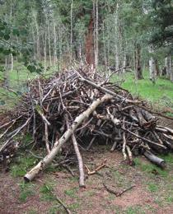
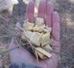
- CLEAN SLASH ACCEPTED-
Divide, Teller County, Colorado SATURDAYS
ONLY
9 am to 4 pm

May 11th thru August 31st, 2024
Saturday 9-4

2024

Divide
Slash Site

Check www.divideslashsite.com
for closures and program updates!

DOs
Max length = 6 feet
Max diameter = 8 inches
DON’Ts
NO stumps, roots, lumber
NO ties, dirt, household trash
NO metals, weeds, grasses
NO bags of pinecones
bark, or pine needles

NO contractor loads

SPONSORS

Teller County

Coalition for the
Upper South Platte

SPONSORS

Park County

Coalition for the Upper South Platte

The Coalition for the Upper South Platte seeks to protect the water quality and ecological health of the Upper South Platte Watershed, through the cooperative efforts of watershed stakeholders, with emphasis placed on community values and economic sustainability.

Volunteer Program: To ensure success and sustainability of this important program, CUSP may need volunteer assistance at the slash collection site.

Please consider making a tax deductible donation to help continue this important program.
Visit with the site manager to volunteer.

FOR MORE INFORMATION 719-748-0033
CUSP@cusp.ws
cusp.ws
www.divideslashsite.com

S A F E F O R E S T S S A F E C O M M U N I T I E S

Not only does defensible space surrounding your home protect your own property, when created with your neighbors, defensible space helps protect your community, your forests and your watershed.

BEFORE Fuels Reduction
AFTER Fuels Reduction

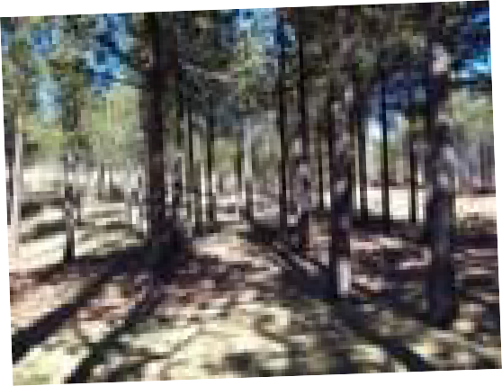
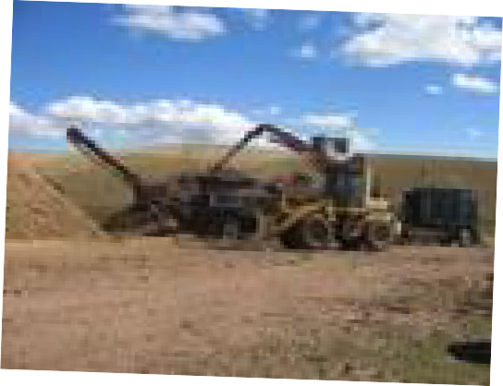
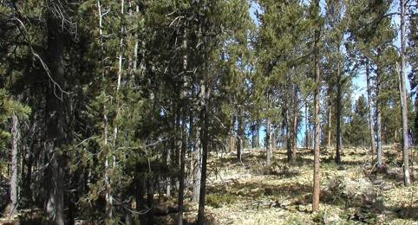
Homeowners can take a number of steps to protect their property and help alleviate the spread of wildland fires. Preventative measures include clearing excess fuel, creating defensible space around their homes and using FireWise practices. Due to Colorado's arid climate and fire-dependent forests, many homeowners and landowners may be particularly vulnerable to wildfires. It is important to keep this threat in

Bring your slash from thinning to the Slash Collection Site
Protect your community!
Location: Just east of the interaction of Hwys 24 & 67 in Divide, take Hybrook Rd South. The site is on the left past the Post Office.

Fee: $20.00 per load of slash (a load is considered equivalent to a pickup bed full)

CASH or CHECK only please.

Mulch: mulch is free when available (load yourself)
mind when buying or building a home. Fire is unpredictable. If there are weaknesses in your home's fire protection scheme, fire can gain the upper hand because of some overlooked or seemingly inconsequential factor. By creating a wildfire defensible zone, homes are less vulnerable from this naturally occurring phenomenon and the chance of spreading wildfires is greatly reduced*.
Source: csfs.colostate.edu/pages/wf-protection.html

